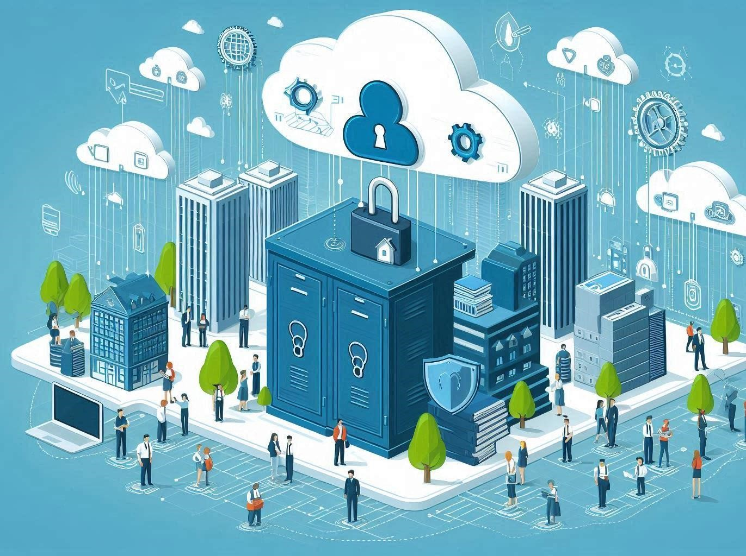

A Research Report on:
“CYBERSECURITY MESH AND CLOUD SECURITY”
CST8912_010 Cloud Solutions Architecture

Submitted By: Submitted To:
- Keshav Lamichhane Prof. Ragini Madan
- Vishal Vekariya
- Meetjitendra Patel
- Arishlaljibh Kakadiya

Date: 15th Nov 2024

Contents
Abstract 3
1. Introduction 4
1.1 Overview 4
1.2 Problem 4
1.3 Objective: 5
2. Literature Review 5
3. Methodology 6
4. Findings 6
4.1 Zero Trust in Cloud Environments: 6
4.2 Companies Adopting Zero Trust Access 8
5. Challenges: 9
5.1. Challenges with Cybersecurity Mesh Architecture (CSMA) 9
5.2 Limitation in implementing Zero Trust access in Azure 10
6. Solutions 10
6.1. Solutions of challenges faced with CSMA 10
6.2 Solution for Zero Trust Access Failure in Azure 11
7. Discussion 13
8. Conclusion 14
9. References: 16

Abstract
In this report, we, the students at Algonquin College: Keshav Lamichhane, Vishal Vekariya, Meetjitendra Patel, and Arishlaljibh Kakadiya, examined the significance of Cybersecurity Mesh Architecture (CSMA) in enhancing cloud security as part of the research report submission.
Traditional security measures that rely on physical perimeters are insufficient as more and more enterprises rely on cloud computing. By combining several security techniques into a coherent system, CSMA provides a flexible and adaptive approach. The risk of unwanted access is decreased by CSMA's implementation of a zero-trust paradigm, which guarantees that every user and device is regularly validated. Our research demonstrates how CSMA improves threat detection, streamlines security administration, and enables various security systems to operate together seamlessly. To show how successful CSMA is at tackling contemporary cybersecurity issues, we gathered information through surveys, case studies, and literature reviews. The importance of CSMA in safeguarding cloud systems is emphasized in this paper, which also explores potential directions for future study, such as combining AI and machine learning to improve security even further.
Our research is intended to advance knowledge about practical cloud security measures. In our opinion, adopting CSMA is essential for businesses to be ahead of new risks in the constantly changing digital environment.

1. Introduction

1.1 Overview
With the advancement in modern technology and requirements, the necessity of managing resources remains very critical. Modern days’ data and system security needs must keep up with the ever-changing technological environment. The use of a fixed perimeter, which underpins traditional security concepts, is no longer adequate for the modern day. We see that the adoption of cloud computing, remote workforces, and interconnected digital ecosystems by enterprises has made it highly essential to adopt more adaptable and flexible security measures. So, there comes the useful situation needing cloud security and cybersecurity mesh.
According to Gartner, a security concept is called Cybersecurity Mesh Architecture (CSMA). A scalable and modular method of expanding security controls, even to widely dispersed assets, is how Garner puts it (AlgoSec | Cybersecurity Mesh Architecture (CSMA) Explained, 2024).
Equipping every device in your network with a personal security guard is known as cybersecurity meshing. We all know that many traditional security solutions cover our computer, smartphone, or server with a single, large fence. However, each item, such as a computer, has its defenses, such as firewalls and protection tools, and with their protection, the other devices can remain safe even in any catastrophic event of an attack on one of them. This more intelligent method makes sure that each component of the network is adequately safeguarded while taking the network (Insight Editor, 2023).
The comparison table below shows how cybersecurity mesh approach is different from traditional one.
Aspect Traditional Security Cybersecurity Mesh
Security Perimeter | Focuses on a fixed, centralized perimeter (e.g., firewall). | Ensures security across individual nodes or devices, enabling decentralized protection.
Adaptability to Difficult to scale and adapt Particularly designed for dynamic cloud and
Cloud to cloud-native or hybrid hybrid environments, allowing smooth and environments. spontaneous security adjustments.

1.2 Problem
Many organizations face challenges with complex and costly security systems due to the use of multiple independent tools, making it difficult to monitor cybersecurity risks. Businesses required Cybersecurity Mesh Architecture (CSMA) since their networks are becoming more complicated and vulnerable as they grow outside of physical spaces. Cyberattacks might potentially target every new access point, resulting in enormous financial losses estimated to exceed $6 trillion a year. Through the extension of security over the entire network with a single technological approach, CSMA is capable of providing a workable and flexible solution that enables enterprises to successfully manage risks while integrating third-party services and launching new initiatives. It is evident that the frequency of ransomware assaults has increased to every 11 seconds, while phishing tactics have increased by 600% in recent years, underscoring the weakness of the IT infrastructure in place. On top of that, zero-day attacks—which employ novel techniques—present a serious risk. A record 66 zero-day assaults were initiated in 2021, more than twice as many as in 2020. These are some of the ever-existing problems in the field of cloud computing (What Is Cybersecurity Mesh? Applications and Advantages, n.d.). Cybersecurity Mesh Architecture (CSMA) addresses this issue by creating a flexible and collaborative security ecosystem, allowing various security solutions to interoperate through shared layers like policy management, centralized security intelligence, and identity management. This approach effectively combines centralized and decentralized security methods, enhancing overall protection for modern enterprises (AlgoSec | Cybersecurity Mesh Architecture (CSMA) Explained, 2024).

1.3 Objective:
To demonstrate how Cybersecurity Mesh Architecture (CSMA) improves defense against changing cyberthreats in cloud environments and strengthens cloud security.
To demonstrate how CSMA makes it possible for security solutions to be seamlessly integrated for efficient risk management in cloud services.

2. Literature Review
Gartner explained CSMA in "Top Strategic Technology Trends for 2022”. He pointed enhancing security across multiple locations and assets can be done in a flexible and scalable manner with cybersecurity mesh architecture (CSMA). It enables multiple security solutions to work together by giving important services including a shared identity system, security analysis, intelligence, automation, and triggers, along with centralized policy administration and coordination. To put it another way, CSMA makes it easier to safeguard everything, everywhere, by integrating various security tools and processes. This helps organizations increase their security (What Is Cybersecurity Mesh and How Can It Help You? | TechTarget, n.d.). By assisting businesses in putting up a multi-layered defense against cyberattacks, CSMA increases the difficulty of network breaches for intruders. A device-centric approach to security will replace the conventional perimeter model as the new benchmark for a safe and flexible cloud environment as cyber threats grow. The cybersecurity mesh market is expected to develop at a compound annual growth rate (CAGR) of 28.6%, from $0.9 billion in 2023 to $2.6 billion by 2027 (Andriy Varusha, 2024).
As published in a survey paper on cybersecurity survey, it has been mentioned that with the cybersecurity mesh transition from conventional centralized models to a decentralized structure that prioritizes the protection of individual assets independent of their location, Cybersecurity Mesh Architecture (CSMA) represents a significant leap in cloud security. Implementing a zero-trust model, CSMA treats all assets as untrusted by default, requiring continual authentication and authorization for access. This method makes it possible to take a more targeted approach to security and makes real-time modifications based on threat intelligence, which is crucial for dealing with threats that change over time in cloud environments. Through the promotion of secure collaboration and the utilization of cutting-edge technologies like strong encryption and software-defined perimeters, cloud security management, or CSMA, creates a strong security framework that improves resilience and adaptability, thereby fortifying an organization's security measures against the difficulties presented by cloud computing (RamosCruz et al., 2024).
Implementing a cybersecurity mesh promotes a zero-trust model, ensuring uniform security across all resources and helping in the defense against emerging threats. According to predictions, this strategy might enable more than half of all security events and minimize the financial effect of security incidents by 90% (Cloud Security Trends: What Is Cybersecurity Mesh?, n.d.).

3. Methodology
This research employs a qualitative and analytical method to investigate the efficiency of Cybersecurity Mesh Architecture (CSMA) in boosting cloud security.
Literature review: The establishment of a theoretical framework for CSMA's function in contemporary security practices involved a thorough analysis of research, reports, and industry papers on CSMA and cloud security, with a particular emphasis on Gartner's reports, cybersecurity journals, and industry surveys.
Analysis of Case Studies: To assess CSMA's effects on cloud security, case studies from businesses that have used the technology were examined prioritizing how well the technology mitigates threats, streamlines security procedures, and recovers fallout from cyber disasters.
Data Collection: Information regarding the adoption rates of CSMA, its predicted market growth, and its function in handling cybersecurity incidents was all collected from already published surveys and papers from valid sources like Gartner.

4. Findings
The following are the major findings of my research:
4.1 Zero Trust in Cloud Environments: CSMA uses a zero-trust security model that is particularly used for cloud environments, which are made up of dispersed resources across several devices and locations. This means that, whether they are inside or outside the network, all users, devices, and services in the cloud should be regarded as potentially untrusted. The risk of unauthorized access or data breaches is greatly decreased when continuous authentication and authorization are applied to cloud services, guaranteeing that only authenticated and authorized access is permitted (Shree N, n.d.).
Zero Trust is a key component of the construction of CSMA (Cybersecurity Mesh Architecture). By verifying their identification and authorization, Zero Trust aims to ensure that only authorized individuals or devices have access. Because CSMA offers scalable and adaptable tools and procedures that can expand to meet various security requirements, it facilitates the adoption of Zero Trust (TerryLanfear, n.d.).
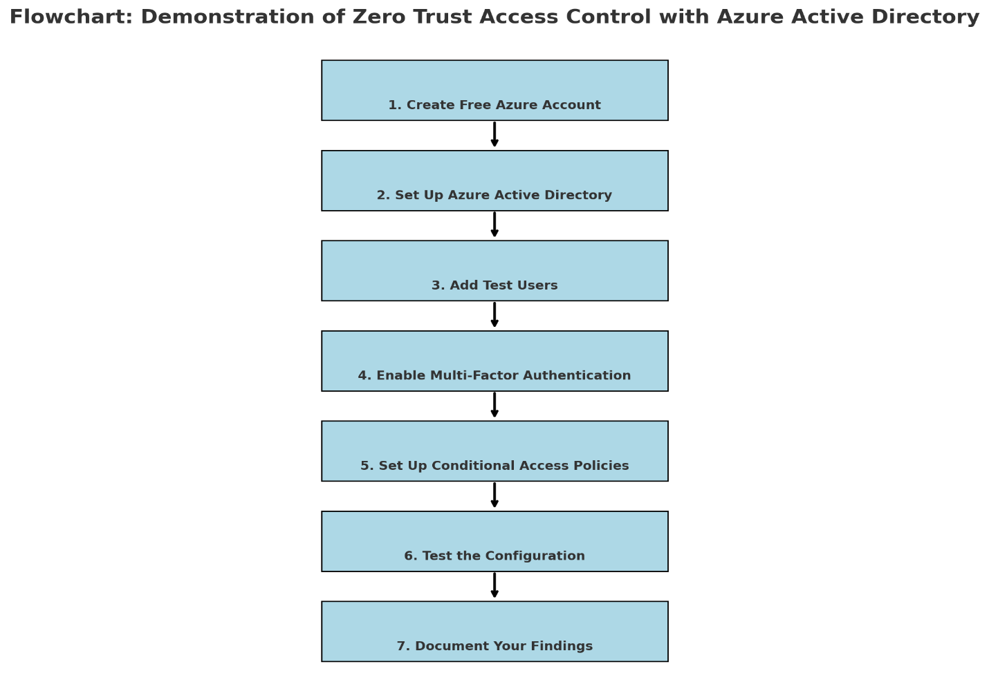
Using a combination of authentication, permission, and security controls, Azure Zero Trust access continually verifies each access request, regardless of where it comes from.
Explicit Verification: Azure Active Directory (Azure AD) is used to verify each user and device. Before allowing access, this entails confirming the user's identification and the device's condition. To make sure that access is only allowed under certain circumstances, Multi-Factor Authentication (MFA) and Conditional Access restrictions are implemented (TerryLanfear, n.d.).
Least Privilege Access: Users are only granted the permissions they require through the implementation of Role-Based Access Control (RBAC), which guarantees that they can only access the information they require.
Breach: Access to critical resources is restricted to lower risk in the event of a potential security compromise. Azure Firewall, Azure Defender, and Network Security Groups (NSGs) are essential tools that assist in threat monitoring and defense mechanism. Azure Key Vault is used to encrypt data, and end-to-end encryption protects data both during storage and network transmission (TerryLanfear, n.d.).

4.2 Companies Adopting Zero Trust Access
All the companies listed below incorporate Zero Trust access into their CSMA architecture:
Twingate: Twingate was established in 2018 and employs a Zero Trust strategy to improve network security using a software-only solution. Twingate uses user identity verification to ascertain access entitlements rather than conventional network IP addresses. Before allowing access to systems, it continuously verifies several variables, including time and location. By guaranteeing that security is maintained across numerous access points without necessitating infrastructure change, this decentralized paradigm works well with CSMA (Jackson, 2023).
CloudFlare: CloudFlare's Zero Trust solution offers a variety of Internet security services with an emphasis on preventing malware, phishing attacks, and data loss. By implementing identity-based security restrictions at every point of access, the Cloudflare One platform enables users to access resources without the usage of conventional VPNs. By distributing the security of each access point, this method complies with CSMA and guarantees the protection of resources in both on-site and distant settings (Jackson, 2023).
Cisco: Cisco's Zero Trust approach protects business apps and data both locally and remotely, offering end-to-end security. Cisco's Zero Trust solutions continuously monitor for any possible threats by verifying users and devices before allowing access using powerful security analytics. A CSMA framework, in which each access attempt is carefully examined to safeguard all digital environments from potential threats, easily incorporates this concept (Jackson, 2023).
Interoperability Across Cloud Services: The ability of CSMA (Cybersecurity Mesh
Architecture) to connect various security tools and services is one of its key advantages for cloud security. This implies that several cloud platforms, such as Infrastructure as a Service (IaaS), Platform as a Service (PaaS), and Software as a Service (SaaS), can cooperate under a single security framework. CSMA makes it easy for companies to have a consistent and unified security approach for all their cloud resources by ensuring that security measures are seamlessly coordinated across all platforms, whether they are hybrid or multi-cloud enterprises.
Adaptive Cloud Security: Particularly useful in cloud environments where traditional perimeter-based security models find it difficult to keep up with the rate of change, CSMA offers an adaptable and customized approach to security. Businesses can scale their security measures instantly thanks to CSMA (Shree N, n.d.).
Using CSMA to Handle Security Tool Sprawl A major obstacle to traditional cloud security approaches is the spread of disparate security solutions, which results in ineffectiveness. The answer provided by Cybersecurity Mesh Architecture (CSMA) is the integration of these disparate solutions into a unified and interoperable security architecture. This strategy improves the efficacy of cloud security measures, lowers operating expenses, and streamlines security operations (Alexi, 2024).
Advanced Detection and adaptable Access Control: By facilitating faster responses, more effective threat detection, and adaptable access control, cloud security is improved by CSMA in a well-organized manner (Alexi, 2024).
The architectural diagram of CSMA architecture by Gartner is presented below.
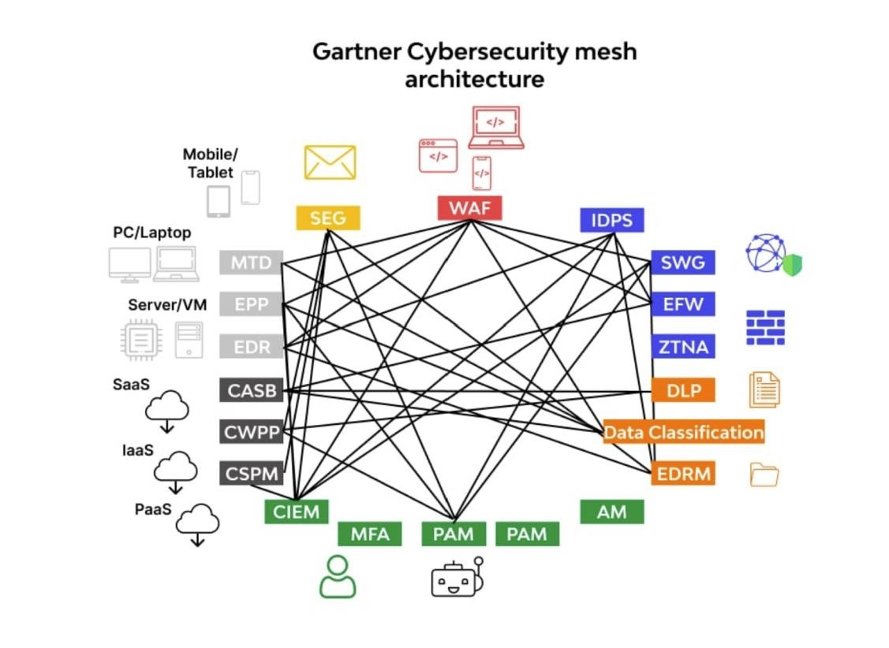
Image source:
https://assets.websitefiles.com/5ff66329429d880392f6cba2/6283d2273969ea65eab8f831_Cybersecurity%20Mesh%20Archite cture.jpg

5. Challenges:
5.1. Challenges with Cybersecurity Mesh Architecture (CSMA)
Our group has researched the challenges involved in implementing Cybersecurity Mesh Architecture (CSMA) and found that it requires a substantial initial investment in both technology and expertise. Integrating CSMA into existing systems can be especially challenging for businesses with numerous third-party applications or legacy infrastructure (Alexi, 2024). Effective management of CSMA relies on a skilled workforce with a deep understanding of cloud security, zero-trust frameworks, and CSMA itself. However, companies often struggle to find employees with the specialized knowledge needed to maintain this decentralized and adaptable security framework.
To streamline security, CSMA consolidates multiple security technologies into a single mesh, but this integration requires careful planning to avoid redundancy and inefficiencies. If legacy security systems are not properly integrated or replaced, the risk of tool sprawl remains a significant concern (Ramos-Cruz, Andreu-Perez, & Martínez, 2024). Additionally, real-time threat detection and rapid response coordination present difficulties within cloud environments. Cloud systems are inherently dynamic, which means security protocols must frequently be adjusted to address evolving threats effectively (Varusha, 2024).
Operating in multi-cloud or hybrid environments further complicates security management, as different providers may have unique security requirements and architectures. This makes it challenging to maintain consistent security policies across platforms. Moreover, as CSMA scales with cloud resources, the increased demand on system performance can become an issue, especially if multiple security checks and authentication procedures are applied continuously. These demands may lead to performance bottlenecks if not properly managed (Insight Editor, 2023).
5.2 Limitation in implementing Zero Trust access in Azure
A key challenge when adopting a Zero Trust model with a student account in Azure is the limited access to the Azure subscription. Student accounts typically come with restricted permissions, which means they may not have full administrative rights to configure and manage security settings, including the implementation of Zero Trust policies. This limited access can prevent students from performing necessary tasks like adjusting user permissions, setting up conditional access policies, or managing identity verification across resources. To address this, it may be necessary to work closely with faculty or administrators who have higher access levels to help configure and implement the required security measures.
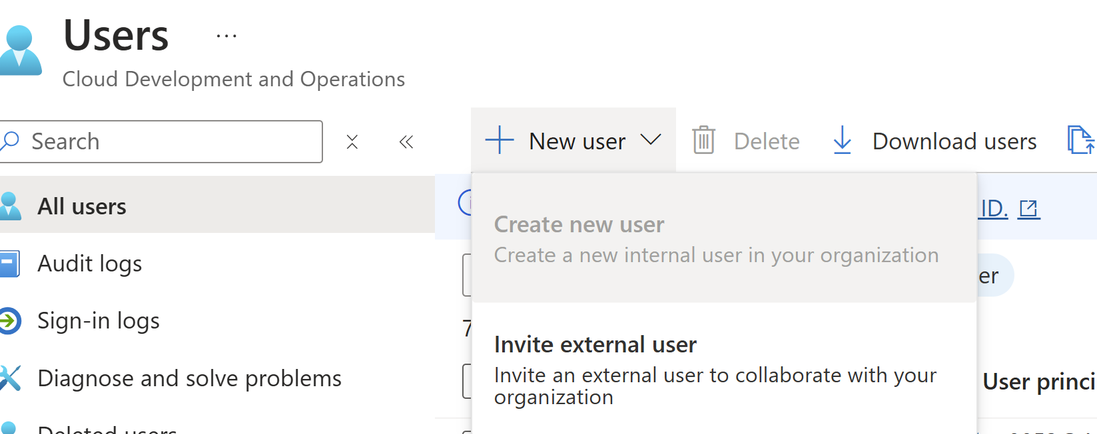
Figure 1 Issue with cresting users in Azure Active Directory
Our research highlights that while CSMA offers a robust framework for modern cloud security, addressing these challenges requires strategic planning and the right technical expertise.

6. Solutions
6.1. Solutions of challenges faced with CSMA
Based on our research and discussions, our group has identified several solutions where CSMA can effectively address the challenges mentioned in the previous section. To manage the complexity of implementing and integrating CSMA, organizations can adopt a phased approach, starting with critical systems and gradually expanding coverage. This allows security teams to adapt to CSMA at a manageable pace, facilitating a smoother transition. Additionally, choosing vendors that adhere to open standards can improve compatibility and simplify cross-platform integration (Alexi, 2024).
Investing in staff training on cloud-native security practices, identity management, and zero-trust principles can help build the necessary internal expertise. Alternatively, organizations can utilize managed security services, providing access to expert support without the need for in-house specialization, allowing internal teams to focus on primary responsibilities (Shree, n.d.).
To reduce tool sprawl, organizations should carefully evaluate their existing security tools, retaining only those that align with CSMA’s goals. CSMA emphasizes interoperability, so ensuring that all tools can operate within a single framework minimizes redundancy and increases efficiency (Ramos-Cruz, Andreu-Perez, & Martínez, 2024).
For real-time threat detection and incident response, CSMA offers a centralized view of security across all nodes. Integrating automation tools for threat detection and response further strengthens this capability, allowing CSMA to adjust defenses in real time, thereby reducing response times (Varusha, 2024).
CSMA’s modular and interoperable design enables consistent policy enforcement across multiple cloud platforms. By standardizing policies within a centralized security layer, organizations can ensure that all cloud resources, regardless of the provider, follow consistent security practices. Close collaboration with cloud providers also supports policy alignment by helping organizations understand each provider’s security framework (AlgoSec, 2024).
To maintain performance, organizations can utilize CSMA’s adaptive security features, such as caching frequently requested authorizations and scaling authentication servers as demand increases. While CSMA’s decentralized structure inherently supports scalability, balancing security needs with performance requirements is essential for seamless operation (Insight Editor, 2023).
Our research demonstrates that, with strategic planning and the right tools, CSMA can effectively overcome implementation challenges and enhance cloud security across diverse environments.
6.2 Solution for Zero Trust Access Failure in Azure
Based on our research and findings, we encountered a significant challenge in implementing Zero Trust access as an architectural component of Cybersecurity Mesh Architecture (CSMA) within Azure. The limitation arose due to the restricted access provided by the Azure Active Directory (AAD) student subscription. This restricted access prevented us from configuring and managing the necessary security settings to fully implement Zero Trust policies, such as role-based access control (RBAC), conditional access, and multi-factor authentication (MFA).
As a result, our proposed solution is to simulate a brute force attack within Azure to demonstrate the principles of Zero Trust access in action. By leveraging Microsoft Sentinel, we aim to generate incidents that highlight various stages of an attack, such as Privilege Escalation, Initial Access, and Credential Access, all of which are recognized as part of the MITRE ATT&CK framework. This simulation will allow us to illustrate how Zero Trust controls and monitoring tools like Azure Defender and Sentinel can be used to detect and respond to security threats in real time, even within the limitations of our student Azure subscription.
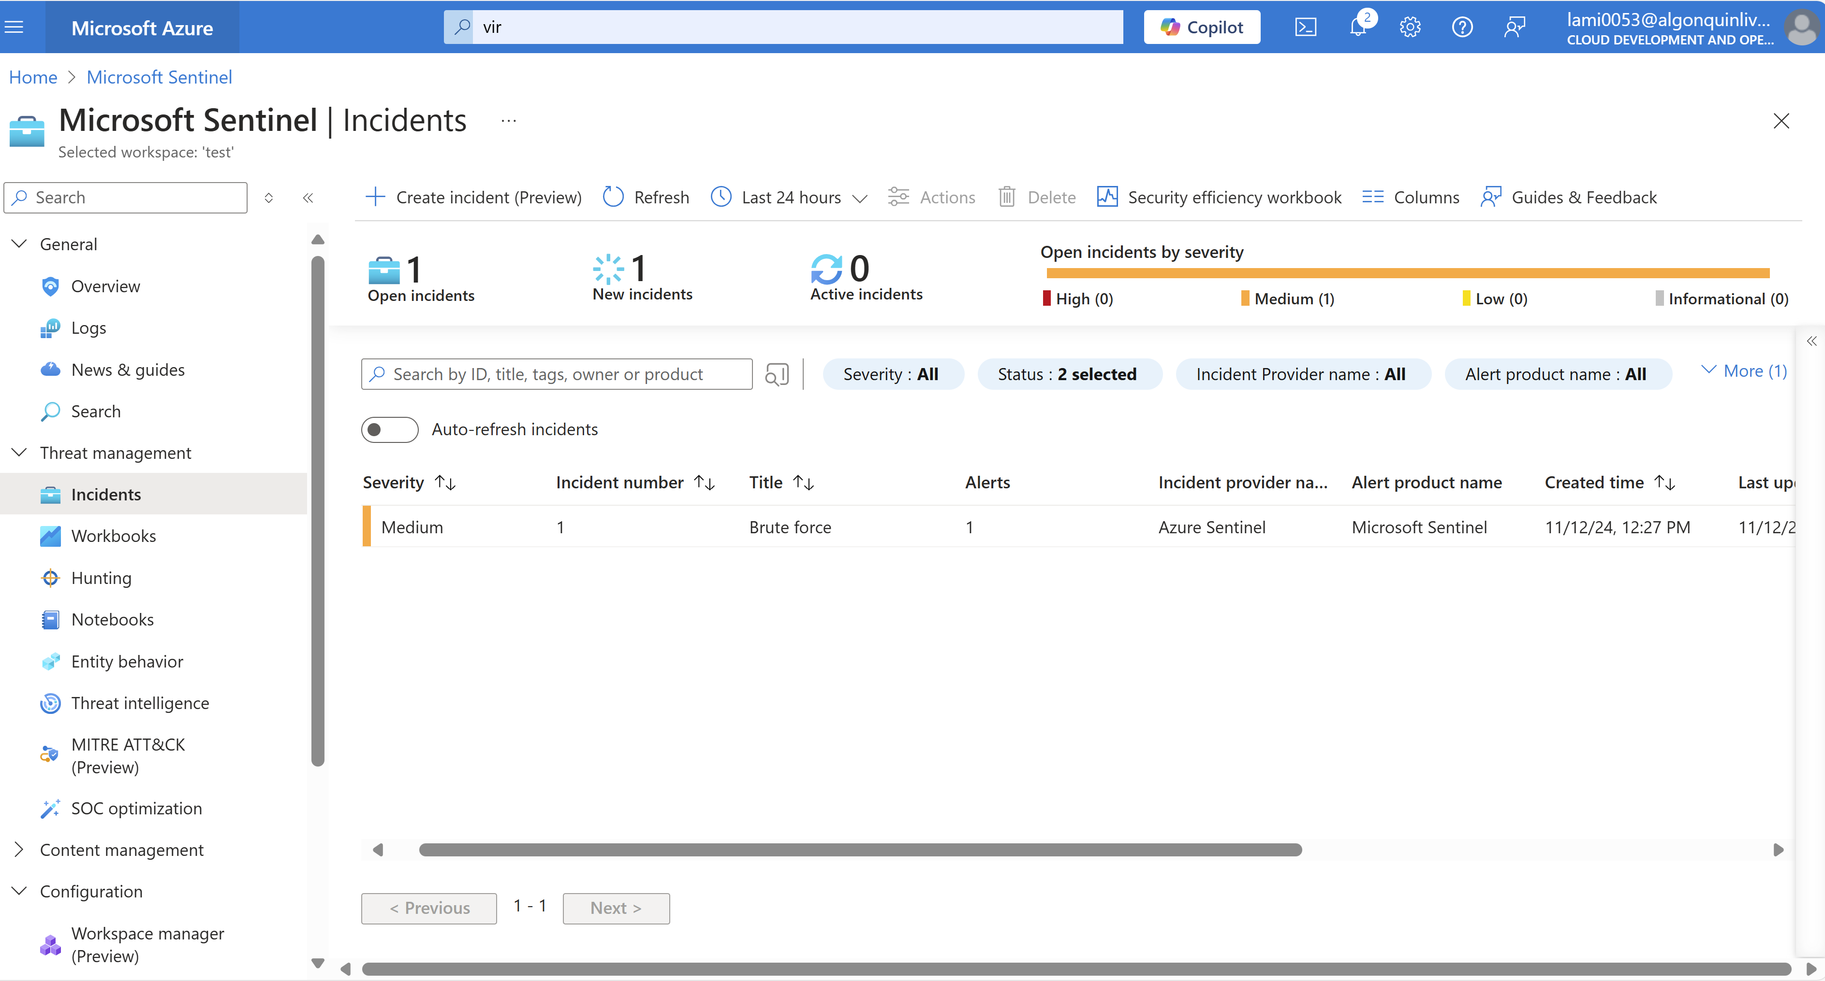
Figure 2 Generating Incidents with Microsoft Sentinel
Investing of the Brute Force attack using Microsoft Sentinel
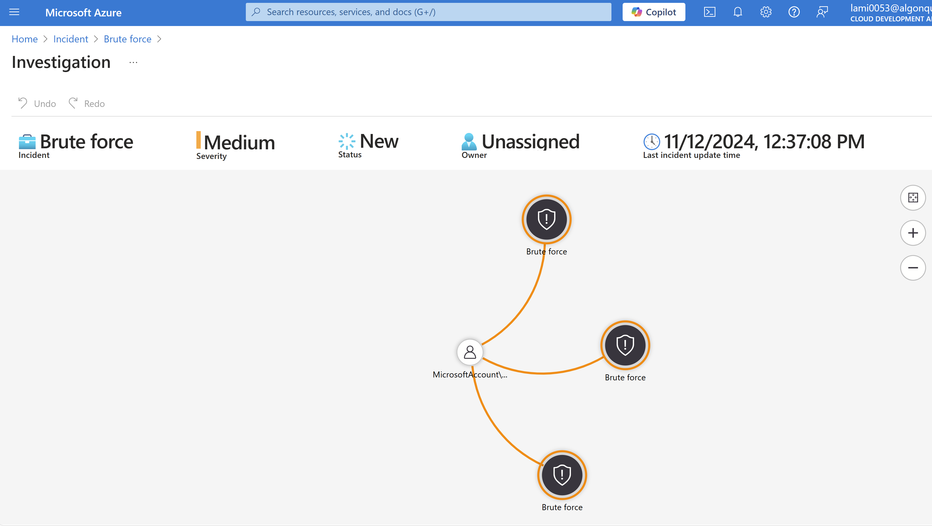
Figure 3 Investing Brute Force Attack

Here’s the approach:
Sentinel data collection: Using Sentinel's agent-based monitoring, we configured data connectors to record Windows security events from the Azure virtual machine. This made it possible for Sentinel's Log Analytics workspace to receive real-time log collection of security events, including unsuccessful login attempts (Event ID 4625) (Acosta, 2023).
Sentinel Analytics Rule Creation: By analyzing Windows security events and concentrating on unsuccessful login attempts, we created a custom rule to identify brute-force assaults. Using MITRE ATT&CK strategies, this rule was set up to detect Credential Access, Privilege Escalation, and Initial Access.
Attack Simulation: Using random passwords, several unsuccessful login attempts were made on the Azure virtual machine to simulate a brute-force attack. Sentinel monitored the pertinent failed login events that resulted from this.
Constant Monitoring and Reaction: Instruments such as Azure Security Center and Azure Sentinel offer real-time environmental monitoring. Continuous protection is ensured by these systems, which examine traffic patterns, identify questionable activity, and automate reactions to any threats (Acosta, 2023).
This approach successfully illustrates how Azure's Microsoft Sentinel and Zero Trust principles may be used to monitor, identify, and address security issues while integrating with CSMA.

7. Discussion
This report highlights the critical role Cybersecurity Mesh Architecture (CSMA) plays in contemporary cloud security. In today's decentralized and distributed cloud environments, the conventional perimeter-based security methods, which were created to safeguard centralized, on-premises systems, are insufficient. These weaknesses are filled by CSMA, which integrates multiple security solutions into a more adaptable, scalable, and flexible security structure.
Regardless of where they are in the network, all users and devices are continually verified and permitted when a zero-trust model is implemented. This approach is especially well-suited to cloud situations.
Moreover, CSMA demonstrates particularly adept at handling the issue of security tool sprawl. Likewise, response times to possible cyber threats are greatly shortened by CSMA's enhanced threat detection and flexible access control measures, which also strengthen the security architecture. This guarantees cloud services' protection against changing cyber threats and makes it easier to respond forcefully to security problems.
Our group discussed the challenges and potential solutions associated with implementing Cybersecurity Mesh Architecture (CSMA) in modern cloud environments. We acknowledged that CSMA demands significant investment in technology and expertise, particularly when dealing with legacy infrastructure and third-party applications.
We discussed the difficulties in adopting CSMA in cloud environments, including the requirement for a significant investment in technology and knowledge, particularly when dealing with third-party apps and legacy infrastructure. We also highlighted the need for qualified staff to manage this adaptable security architecture, pointing out the lack of experts with specific CSMA expertise.
Given the difficulties we encountered when putting Zero Trust into practice, we suggested a different approach that uses Azure Sentinel to simulate brute-force attacks to illustrate its tenets. We were able to replicate Zero Trust's detection and response methods by simulating a brute-force attack. We identified unsuccessful login attempts (Event ID 4625) and created security incidents related to Credential Access, Privilege Escalation, and Initial Access using Sentinel's analytics rules. Despite our inability to fully implement Zero Trust rules, this method allowed us to demonstrate automated alerting, incident response, and real-time threat detection functions within the CSMA framework.
A phased approach to CSMA integration was also investigated, and we suggested a slow transition to this paradigm over time. A major area of focus for CSMA was interoperability among security products, and we talked about assessing current solutions to make sure they complement one another well, cutting down on redundancy and increasing productivity. Additionally, we emphasized the significance of uniform policy enforcement across cloud platforms and real-time threat detection, both of which are critical to CSMA's efficacy in safeguarding contemporary cloud settings.

8. Conclusion
According to this study, as organizations shift away from conventional, centralized systems, Cybersecurity Mesh Architecture (CSMA) becomes increasingly important for safeguarding contemporary cloud settings. CSMA leverages a zero-trust methodology to enhance cloud security by limiting unwanted access, guaranteeing seamless security across several platforms, adjusting to emerging threats, simplifying security tool complexity, and expediting threat detection and response.
Cybersecurity Mesh Architecture (CSMA) offers a modern, flexible framework well-suited to the challenges of securing cloud environments, but its implementation poses several significant hurdles. Our research highlights that integrating CSMA demands substantial investment, technical expertise, and careful planning, particularly for businesses with complex, multi-cloud, or hybrid environments. Legacy systems and tool sprawl can complicate integration, while dynamic cloud settings necessitate frequent security adjustments. However, by adopting a phased approach, investing in staff training, and utilizing open standards, organizations can address many of these challenges effectively. Additionally, managed security services can provide specialized support, easing the burden on in-house teams
In conclusion, CSMA still provides a solid, flexible basis for cloud security, even though Zero Trust implementation was constrained in our situation. Strategic planning, qualified personnel, and ongoing adaptability to the changing threat scenario are essential for the effective deployment of CSMA. Our alternate approach, which used Azure Sentinel to simulate brute-force attacks, illustrated the value of automated threat detection and response and was in line with CSMA's principles to improve cloud security.

9. References:
Insight Editor. (2023, January 2). What is Cybersecurity Mesh? Insight. https://www.insight.com/en_US/content-and-resources/glossary/c/cybersecurity-mesh.html
‌AlgoSec | Cybersecurity Mesh Architecture (CSMA) Explained. (2024). AlgoSec. https://www.algosec.com/blog/cybersecurity-mesh-architecture-csma-explained
‌What Is Cybersecurity Mesh? Applications and Advantages. (n.d.). Fortinet. https://www.fortinet.com/resources/cyberglossary/what-is-cybersecurity-mesh
‌What is cybersecurity mesh and how can it help you? | TechTarget. (n.d.). Security. https://www.techtarget.com/searchsecurity/tip/What-is-cybersecurity-mesh-and-how-can-it-help-you
‌Andriy Varusha. (2024, February 21). Top cloud security trends to protect your business in 2024. Software Development Company - N-IX. https://www.n-ix.com/cloud-security-trends/
‌Ramos-Cruz, B., Andreu-Perez, J., & Martínez, L. (2024). The cybersecurity mesh: A comprehensive survey of involved artificial intelligence methods, cryptographic protocols and challenges for future research. Neurocomputing, 127427. https://doi.org/10.1016/j.neucom.2024.127427
Cloud Security Trends: What Is Cybersecurity Mesh? (n.d.). Security Intelligence. https://securityintelligence.com/articles/cloud-security-trends-cybersecurity-mesh/
Alexi, C. (2024, March 26). Organizations need to constantly update their cloud security protection because cyber criminals are rapidly adapting theirs. One cloud security trend gaining momentum in 2024 is cybersecurity mesh architecture (CSMA), a collaborative ecosystem of tools and controls to secure a modern, distributed en. Linkedin.com. https://www.linkedin.com/pulse/cloud-security-cybersecurity-mesh-architecture-answer-charles-alexi-nkrfc/
‌TerryLanfear. (n.d.). Zero Trust security in Azure. Learn.microsoft.com. https://learn.microsoft.com/en-us/azure/security/fundamentals/zero-trust
‌Jackson, A. (2023, August 9). Top 10 Zero Trust Companies. Cybermagazine.com. https://cybermagazine.com/top10/top-10-zero-trust-companies
‌Acosta, N. (2023, April 13). Investigating Security Events using Microsoft Sentinel and Simulating Password Brute-Force Attack on the Azure VM. Medium. https://medium.com/@neilacostait/investigating-security-events-using-microsoft-sentinel-and-simulating-password-brute-force-attack-e6c5e481387d

‌

